Name: ______Diego Augusto Cruz Rivero________________________ Date: ___14/9/2025____

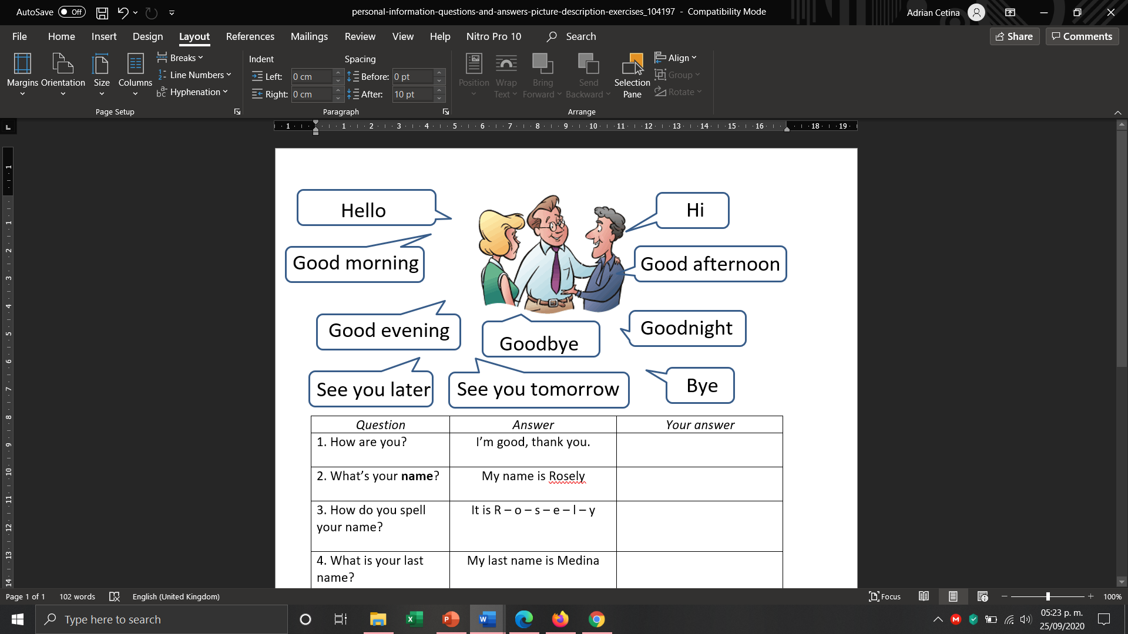

**Instructions:**  Answer the questions with your personal information as in the example. Then use

|  |  |  |
| --- | --- | --- |
| ***Question*** | ***Example*** | ***Your answer*** |
| 1. What’s your **name**? | My name is Rosely | My name is Diego |
| 2. How do you spell your name? | It is R – o – s – e – l – y | It is D - i – e – g - o |
| 3. What is your last name? | My last name is Medina | My las name is Cruz |
| 4. How do you spell your last name? | It is M – e – d – i -n – a | It is C -r – u - z |
| 5. Where are you from? | I’m from Mexico. I’m Mexican. | I’m from Mexico. I’m Mexican. |
| 6. What is your phone number? | My phone number is:  5-6-4 1-2-3 0-9-7-8 | My phone number is:  9-9-9 4-3-2 0-3-8-6 |